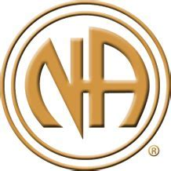 THE WESTEND AREA OF NARCOTICS ANONYMOUS
WEANA 35th Anniversary
Marathon
Marathon

CELEBRATION OF LIFE

TOPIC: OUT WITH THE OLD, IN WITH THE NEW

December 31, 2020 6:00pm – 6:00pm January 1, 2021

Meeting ID: 875 7565 7176 Password: WEANA35 Cash App: $WestEndNA
Website: www.weascna.org Venmo: @WestEndArea-NA

