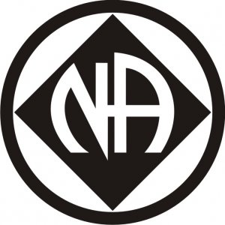WEANA 35TH ANNIVERSARY
  - Winter Solistice Marathon

TOPIC: Surviving the Holidays

Meeting ID: 875 7565 7176

Passcode: WEANA35

December 24 – 25, 2020

6:00pm – 6:00pm

Venmo: @WestEndArea-NA

Cash App: $WestendNA

Website: weascna.org

