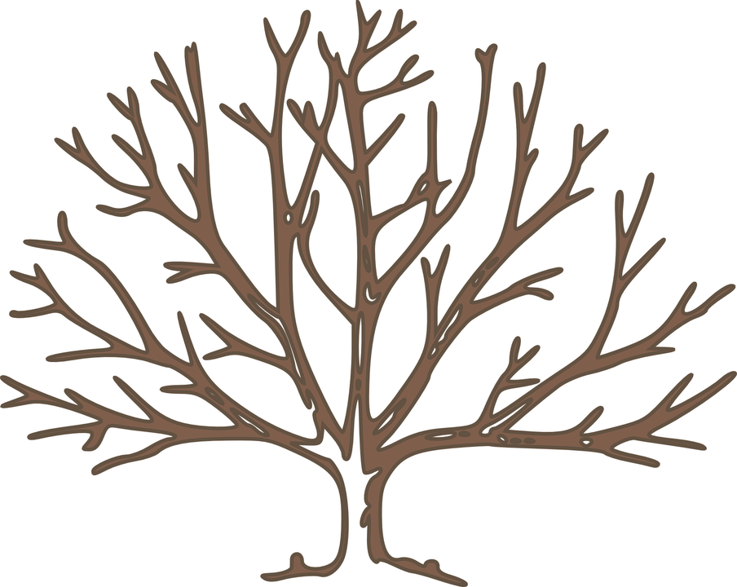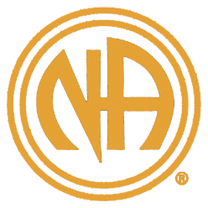

Willie T.

New York

Milton T.

Cinti, OH

Jimmie K.

FOUNDER

Van G.

Atlanta GA

Johnnie W.

MGM, AL

Dutch— NJ

Atlantic City

Harry W.

Portland, OR

Kenneth D.

Durham, NC

Alexia T.

Columbia, SC

**JULY**

**1953**

Bob G.

Hollywood FL

Rico R.

Wash. DC

**WEANA 35 PRESENT**

**HONORING OUR PREDECESSORS**

**STATE TO STATE**

**WEBSITE: WEASCNA.ORG**

**Meeting ID: 575 377 1071**

**Password: WEANA35**

**VENMO: @$WestEndArea-NA**

**Cash App: $WestendNA**

**May 30—31, 2021**

**6:00 pm — 6:00 pm**

**Main Speaker @ 5:00 pm**

**MARATHON MEETING**